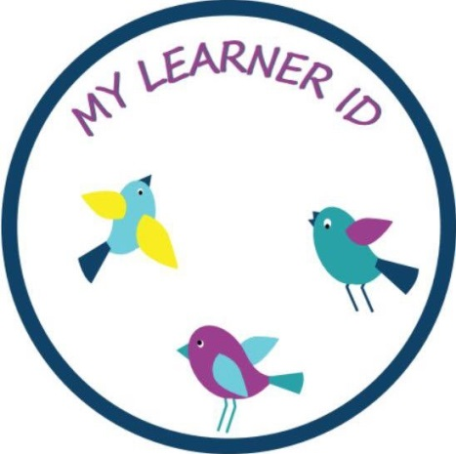
In 2017/2018 Ms Jordan piloted an exciting new programme called My Learner ID with her class and felt it was a great success. Ms Jordan is running this programme again this year in third and fourth class This is a timely programme for learners to “learn how to learn”, to become and to be learners. “My Learner Id”, gives young learners a “voice” and helps children understand and explore how they learn. Importantly it also allows others understand the learning ways of each learner.
“My Learner ID” promotes authentic assessment, assessment for learning and for life, learner well-being, learner voice, learner ownership and learner responsibility. There is more information on the My Learner ID website.

