March 30th – Apr 3rd
Gaeilge:
- 10 mins per day on duolingo( a free online language site/app)
- Watch one programme/cartoon on cúla4 per day

Reading:
- It is very important to keep reading, you can read your own books or the ones you brought home and make sure to keep your book log .
- If you run out of books worldbook – world book online have provided free access to their library. There is a large amount of books on the site and there is a great range of fiction and non fiction books available. This is similar to EPIC which you have been using in school. Remember to add these books to your log.

Spellings:
- Continue with Spellbound and do one unit per week.

Maths:
- Continue with your mental maths , one unit per week.
- Use this time to really learn you tables, it will be a very good use of your time. This week concentrate on your multiplication tables , you can use the following sites to help you;
Topmarks
Timestables.com
Multiplication.com
- look at Mathsweek.ie (click on the ‘ maths at home’ tab) there are some very interesting and fun activities on this site and they are changed daily.

Writing :
- Write a diary entry each day and don’t forget to add your ‘three good things’
- Creative Writing
Have a look at the picture below. Write a story that will involve this picture.

Do your plan first and then write your story.
Remember , take care with your paragraphs, full stops and capital letters. Make sure you read over what you have written .

Geography:
Do a project on a country of your own choice.

Project on a country
- Name of country
- Flag
- Natural features
e.g. mountains
rivers
lakes
beaches etc.
- Man made features
e.g. famous buildings
stadiums
castles
tourist sites etc.
- Famous people from this country
- Main cities
- Interesting facts
- Anything of your own you would like to add
Don’t print out writing from websites. Put it into your own words. It is ok to print pictures.

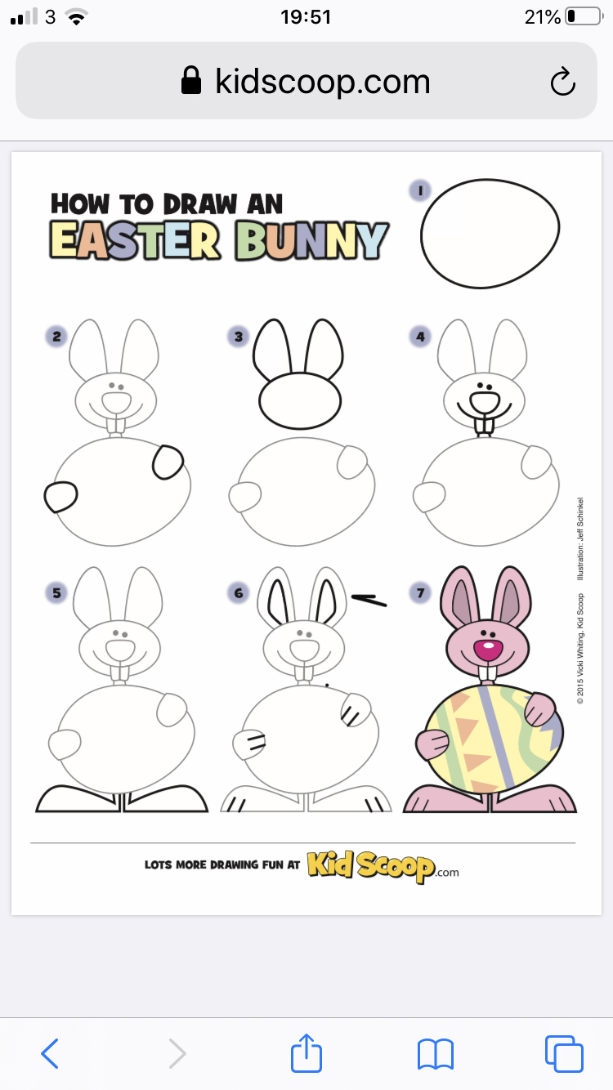
Art: You can follow these steps and make a special card for someone.
Have a great Easter everyone and we will see you all soon.

Apr 20th –Apr 24th
Gaeilge:
- 10 mins per day on duolingo( a free online language site/app)
- Watch one programme/cartoon on cúla4 per day

Reading:
- It is very important to keep reading, you can read your own books or the ones you brought home and make sure to keep your book log .
- If you run out of books worldebook – world book online have provided free access to their library. There is a large amount of books on the site and there is a great range of fiction and non fiction books available. This is similar to EPIC which you have been using in school. Remember to add these books to your log.
Spellings:
- Continue with spellbound and do one unit per week.
Maths:
- Continue with your mental maths , one unit per week.
- Use this time to really learn you tables, it will be a very good use of your time. This week concentrate on your division tables , you can use the following sites to help you;
Topmarks
Timestables.com
Multiplication.com
- look at Mathsweek.ie (click on the ‘ maths at home’ tab) there are some very interesting and fun activities on this site and they are changed daily.

Writing:
- Write a diary entry each day and don’t forget to add your ‘three good things

- You have been writing book reviews in your book log. Now you can;
Write a review of a movie you’ve watched over Easter.

Use the following questions as a guide.
- What is the film’s genre? For example was it Action? Science Fiction? Fantasy? Adventure? Animation? Comedy? Or something else?
- Write a short summary of the film and an explanation of why you liked ( or disliked) it.
- What was your favourite scene?
- Did you find any part of the movie disappointing?
- Describe the character you admired most.
- Describe the character you disliked most.
- Do you have any suggestions as to how the movie could have been better?
- Who would you recommend the movie to?
- Give the movie a star rating( one star terrible , 5 stars exceptional)

History:
- Read over the chapter on Games and Pastimes.

Take a few sheets of paper and make a little book about a particular person, group or type of pastime that had an impact on our history.

Each drawing should have an informative caption e.g.
Jack Charlton who helped Ireland reach the World Cup finals for the first time;
Ken Doherty the first Irish snooker player to the World Championships;
or Mark Pollock the Irish explorer who became the first blind person to reach the South Pole.

You can also choose local people who made an impact in our area in the past and it doesn’t have to be sport it can be music, dancing writing or any other type of pastime in history.

Art
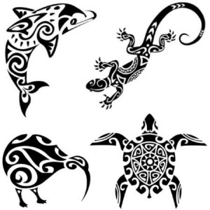

Remember our Maori Art? The Maori got their inspiration from nature. Have a look outside your home , look at the grass,weeds, trees, insects, flowers, water or clouds, or take something else from the nature you see around you to inspire a drawing using the Maori style.

