Dear Parents ,

In expectation of the easing of lockdown restrictions I will be able to return to the school next week. I am planning to go in and put the children’s books and copies that they need into packs. I will have them available for collection on Wednesday between 11am and 1pm. The packs will be in the foyer with the children’s names on them. As you will appreciate we need to continue to observe social distancing when collecting. Also I would ask that you allocate someone to collect your child’s pack if you are unable to do so.

Regards,

Anne Jordan

May 18th – May 22nd
Hi everyone, I really enjoyed seeing you on Wednesday and I am looking for to Monday. Have a pencil and paper with you, your Planet Maths and your Unlocking History.We will be going through this weeks work.

Gaeilge:

I hope everyone is managing to do some Gaeilge, I know it’s hard but even a little everyday will help.
- 1 day - 10 mins day on duolingo( a free online language site/app)
- 1 day - Watch RTE’s Home School Hub and Cula 4 cartoons or programmes
- 3 days - write ‘an nuacht’ times in the week

An Nuacht

Inniu an________________. Inné an ____________. Amárach an ________________. An ( seasúr)_____________ atá ann. Mí_____________atá ann.
(An aimsir) - Tá sé___________ agus ___________.
Chuaigh mé_____________________. Bhí mé__________.
Rinne mé____________________.
D’ith mé___________________.

Here are some words you can use but you can use more words you can remember from school.

An Aimsir Na seisúir
gaofar An tEarrach
an ghriain ag taitneamh An Samradh
ag cur baistÍ An Fómhar
fuar An Geimhreadh
te
tirim Míonna
fliuch Eanáir
scamallach Feabhra
Márta
Gníomhachtaí (actions) Aibreán
Ag imirt rugbaí, iománaíocht, Bealtaine
Camógaíocht, leadóige, peile, Meitheamh
Cluiche ríomhaire,ag deanamh Iúil
obair scoile, ag leamh, ag bácáil, Lúnasa
Ag sugradh sa ghairdín, ag caint Meán Fómhair
le mo chairde Deireadh Fómhair
Mí na Samhna
Mí na Nollag

Reading:
- It is very important to keep reading, don’t forget to keep your book log.

- Remember, if you run out of books World eBook – World Book Online have provided free access to their library. There is a large amount of books on the site and there is a great range of fiction and nonfiction books available.

- If you haven’t done so already another good source of books is ‘borrow box’ which is available through the community library service.

- https://www.librariesireland.ie/ga/node/171

Spellings:
- Continue with Spellbound and do one unit per week.
Maths:
- Continue with your mental maths, one unit per week.
- Spend 5 mins per day practising your tables ( this is always very important)
- Maths week - There are new activities being added to https://www.mathsweek.ie/2019/ every day, so keep an eye out for interesting material and games.
Number and Patterns and Sequences
Third Class

Watch this short clip and it will explain number pattern and sequences to you
https://www.youtube.com/watch?v=7BDHKHXwafQ

Complete pages 130,131 and 132 of your book in a copy.

Fourth Class

Watch the followings clips on patterns

https://www.youtube.com/watch?v=l45rkZHSq_A https://www.youtube.com/watch?v=nKyEnEtNSQA

Complete pages 131 and 132 of your book in a copy.

Note; If you do not have your Planet Maths you may be able to access the eBook on ‘Folensonline’

Writing:
- Don’t forget to write your diary entry each day no matter how small the entries are. It will be very interesting to look back at your diary in years to come and don’t forget to add your ‘three good things’ for each day. Note; this diary is for yourself to keep and read, I will not need to read them.

- This weeks writing is about dragons your art lesson may come is useful for the picture story part of the exercise.

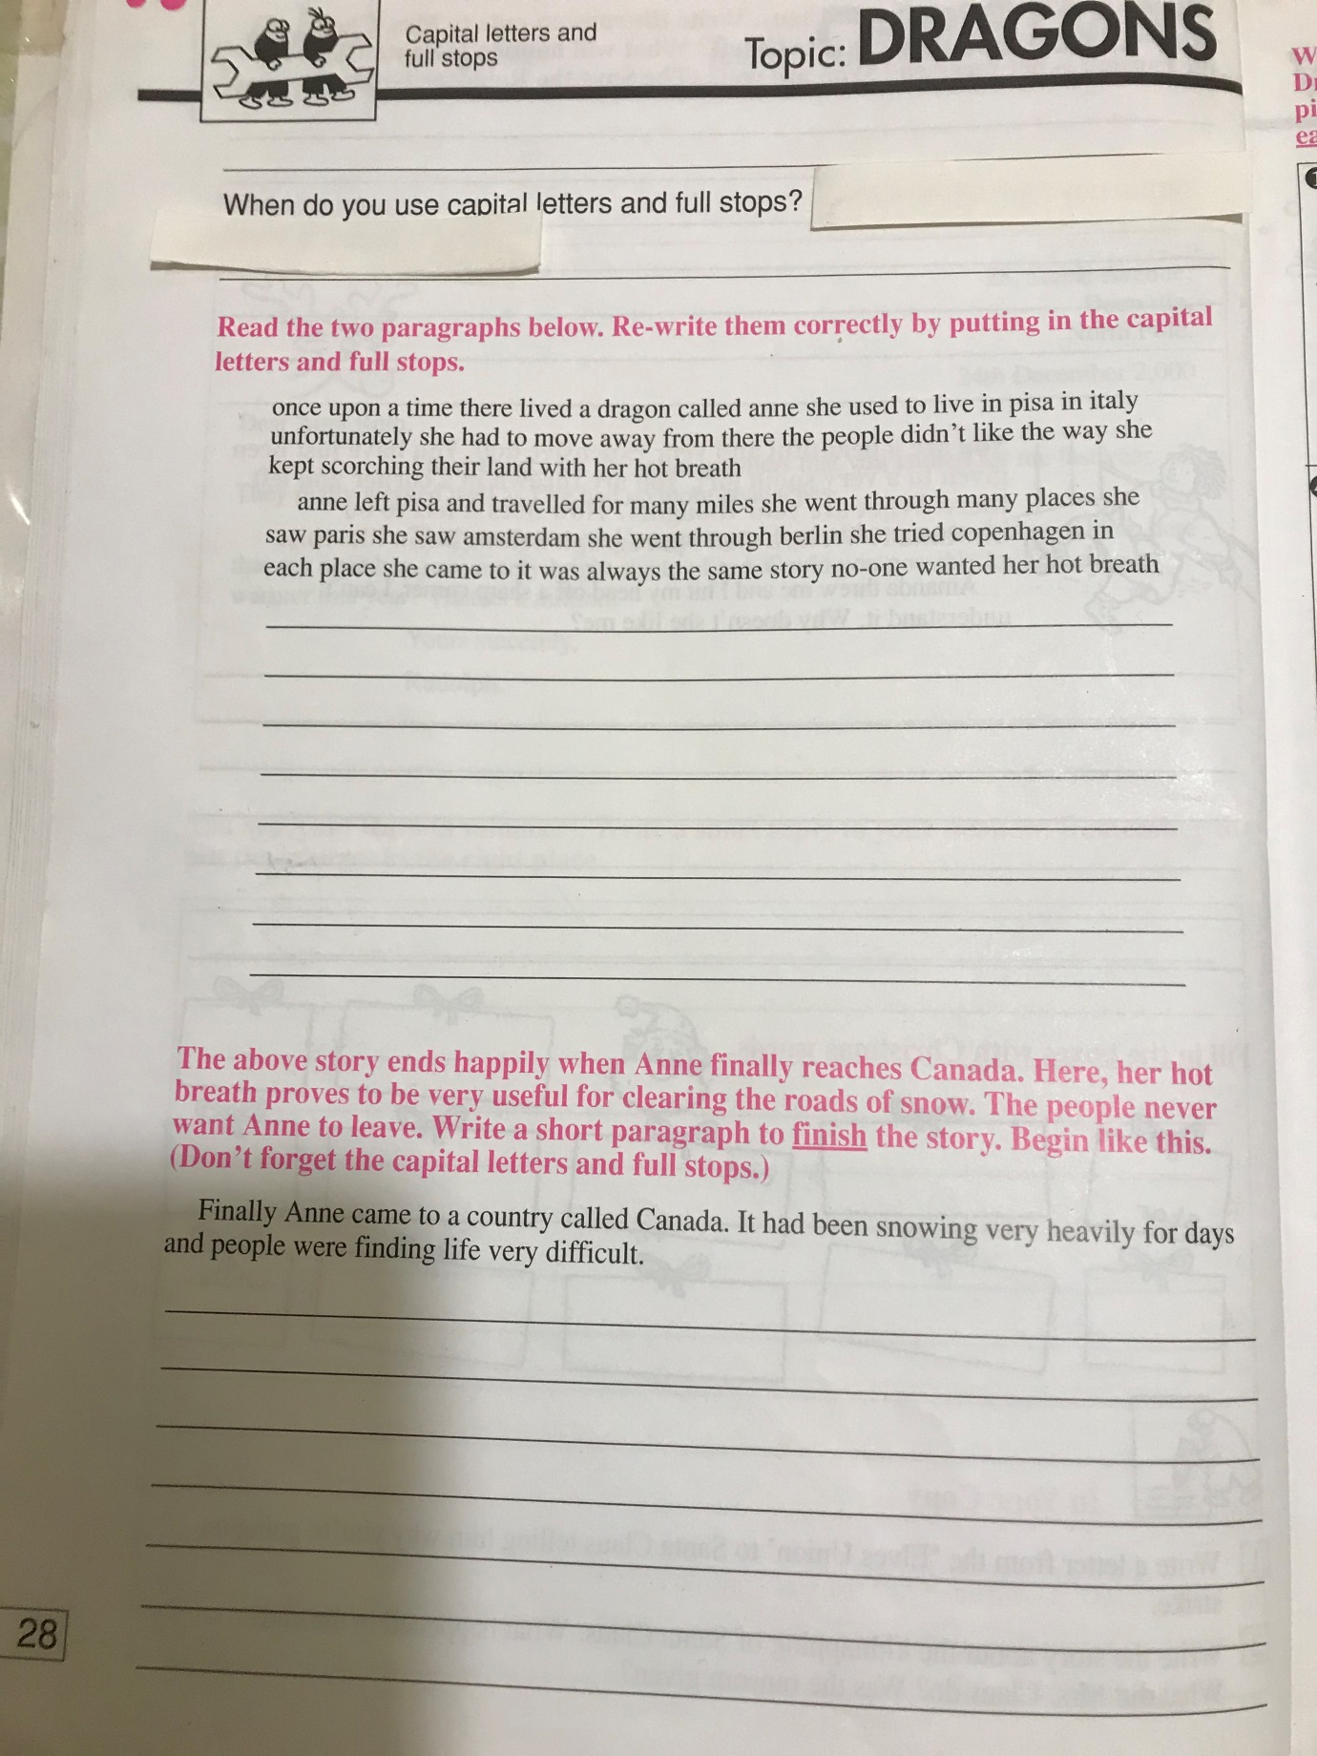

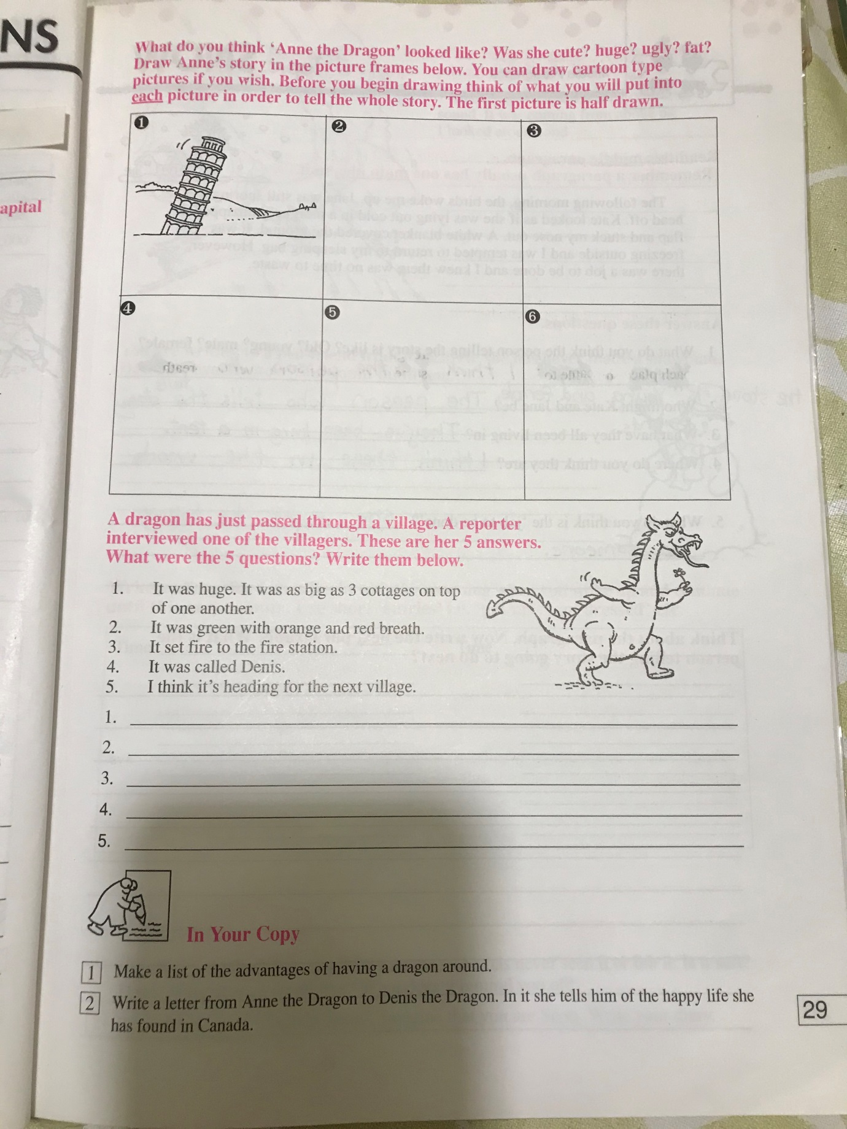
History
Unlocking History; Chapter 11, Stories from around the World.

Music
The tutor for this week is Mark Sheehan. In the first video, Mark is taking children on a musical adventure around the world, and in the second link he is giving a fun demonstration of the electric guitar. I hope everyone will enjoy these videos.

Part 1 - World Music

https://www.dropbox.com/s/boetcfe2046jz69/KidsCeolWorldMusicGame1%20%20%20%20.mp4?dl=0

Part 2 - The Electric Guitar

https://www.dropbox.com/s/n3dcmy73r0xhvwu/KidsCeolElectricGuitar%20.mp4?dl=0

Art
Look at your writing task, this may come in useful for your picture story/comic strip.

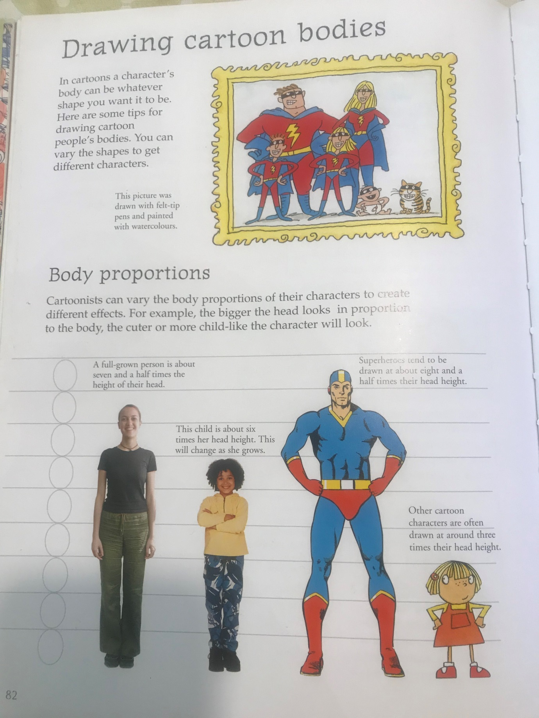

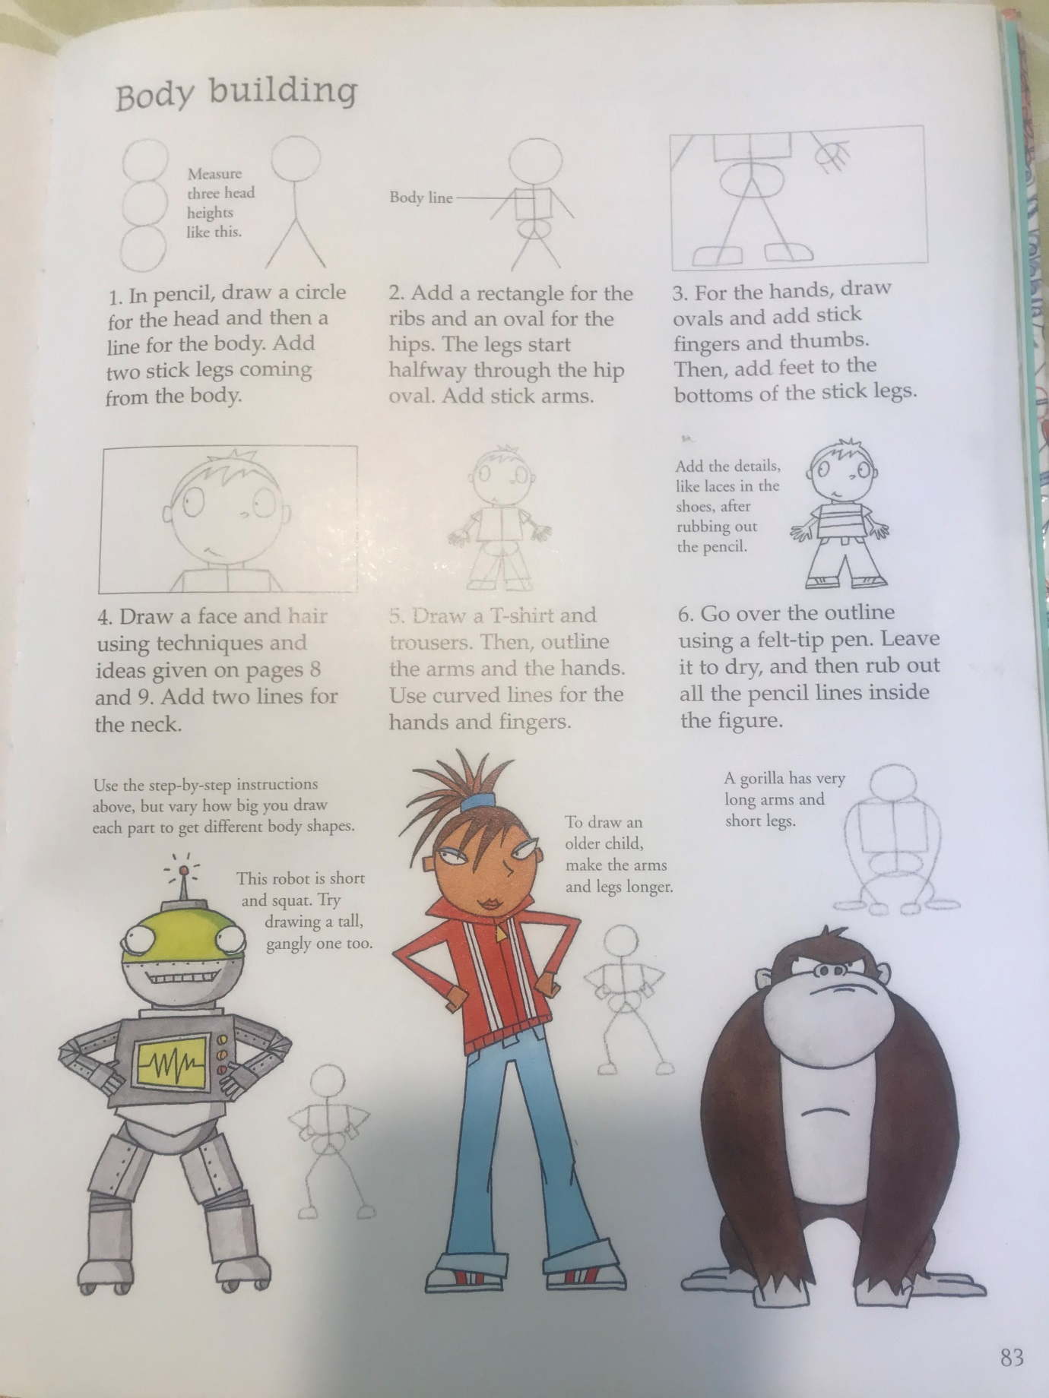

P.E
GAA primary games
Hurling skill challenge video https://www.youtube.com/watch?v=_ZkE-uzEZL8
Football skill challenge video https://youtu.be/MTajywvDQmM

