June 2nd – June 5th
4th
We will be going through this on Tuesday so have a pencil and paper, Planet Maths, Just Grammar, Bua na Cainte and Matilda with you.
Gaeilge:

- 1 day - 10 mins day on duolingo( a free online language site/app)
- 1 day - Watch RTE’s Home School Hub and Cula 4 cartoons or programmes
- 1 day - write ‘an nuacht’

An Nuacht

Inniu an________________. Inné an ____________. Amárach an ________________. An ( seasúr)_____________ atá ann. Mí_____________atá ann.
(An aimsir) - Tá sé___________ agus ___________.
Chuaigh mé_____________________. Bhí mé__________.
Rinne mé____________________.
D’ith mé___________________.

Here are some words you can use but you can use more words you can remember from school.

An Aimsir Na seisúir
gaofar An tEarrach
an ghriain ag taitneamh An Samradh
ag cur baistÍ An Fómhar
fuar An Geimhreadh
te
tirim Míonna
fliuch Eanáir
scamallach Feabhra
Márta
Gníomhachtaí (actions) Aibreán
Ag imirt rugbaí, iománaíocht, Bealtaine
Camógaíocht, leadóige, peile, Meitheamh
Cluiche ríomhaire,ag deanamh Iúil
obair scoile, ag leamh, ag bácáil, Lúnasa
Ag sugradh sa ghairdín, ag caint Meán Fómhair
le mo chairde Deireadh Fómhair
Mí na Samhna
Mí na Nollag

Bua na Cainte

Pages 147 and 148, have your book at Zoom and we will go through it.

Reading:
- It is very important to keep reading, don’t forget to keep your book log.
- Try logging onto Epic , the class code was e mailed to you

- If you haven’t done so already another good source of books is ‘borrow box’ which is available through the community library service.

- https://www.librariesireland.ie/ga/node/171
Novel – Matilda

Read Chapters 7,8 and 9 we will be reading chapter 10 on Zoom on Thursday
Work sheet 8 and 9 and we will take answers at Zoom on Thursday

Spellings:
- Continue with Spellbound and do one unit per week.
Maths:
- Continue with your mental maths, one unit per week.
- Spend 5 mins per day practising your tables ( this is always very important)
- Maths week - There are new activities being added to https://www.mathsweek.ie/2019/ every day, so keep an eye out for interesting material and games.
Operations Topic 25 pg 152

Pg 152 B Q 1,2, and 3
C Q 1,2,3 and 4

Pg 154 A Q 1

Q2

Q3

Q4

C Q2

Q3

Q4

Pg 155 A Q1
Q2
Q3
Q4

B Q1
Q2

Writing:
- Don’t forget to write your diary entry each day no matter how small the entries are. It will be very interesting to look back at your diary in years to come and don’t forget to add your ‘three good things’ for each day. Note; this diary is for yourself to keep and read, I will not need to read them.

Just Grammar
Page 30 and 31
Handwriting Book
Continue on for 2 pages

Science
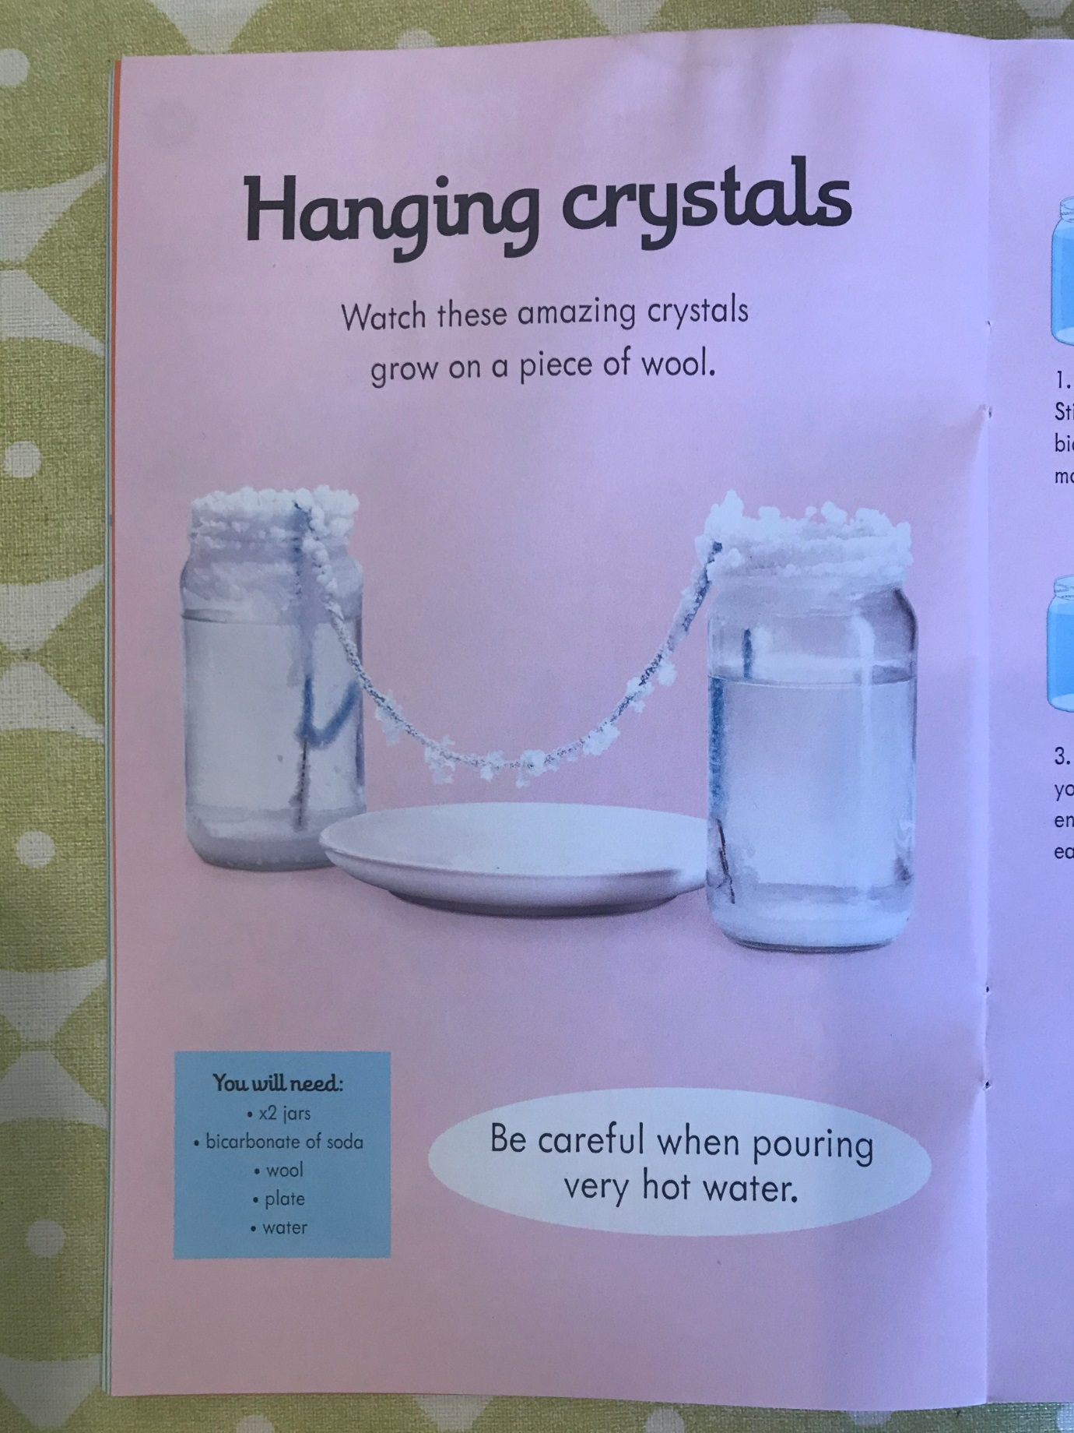

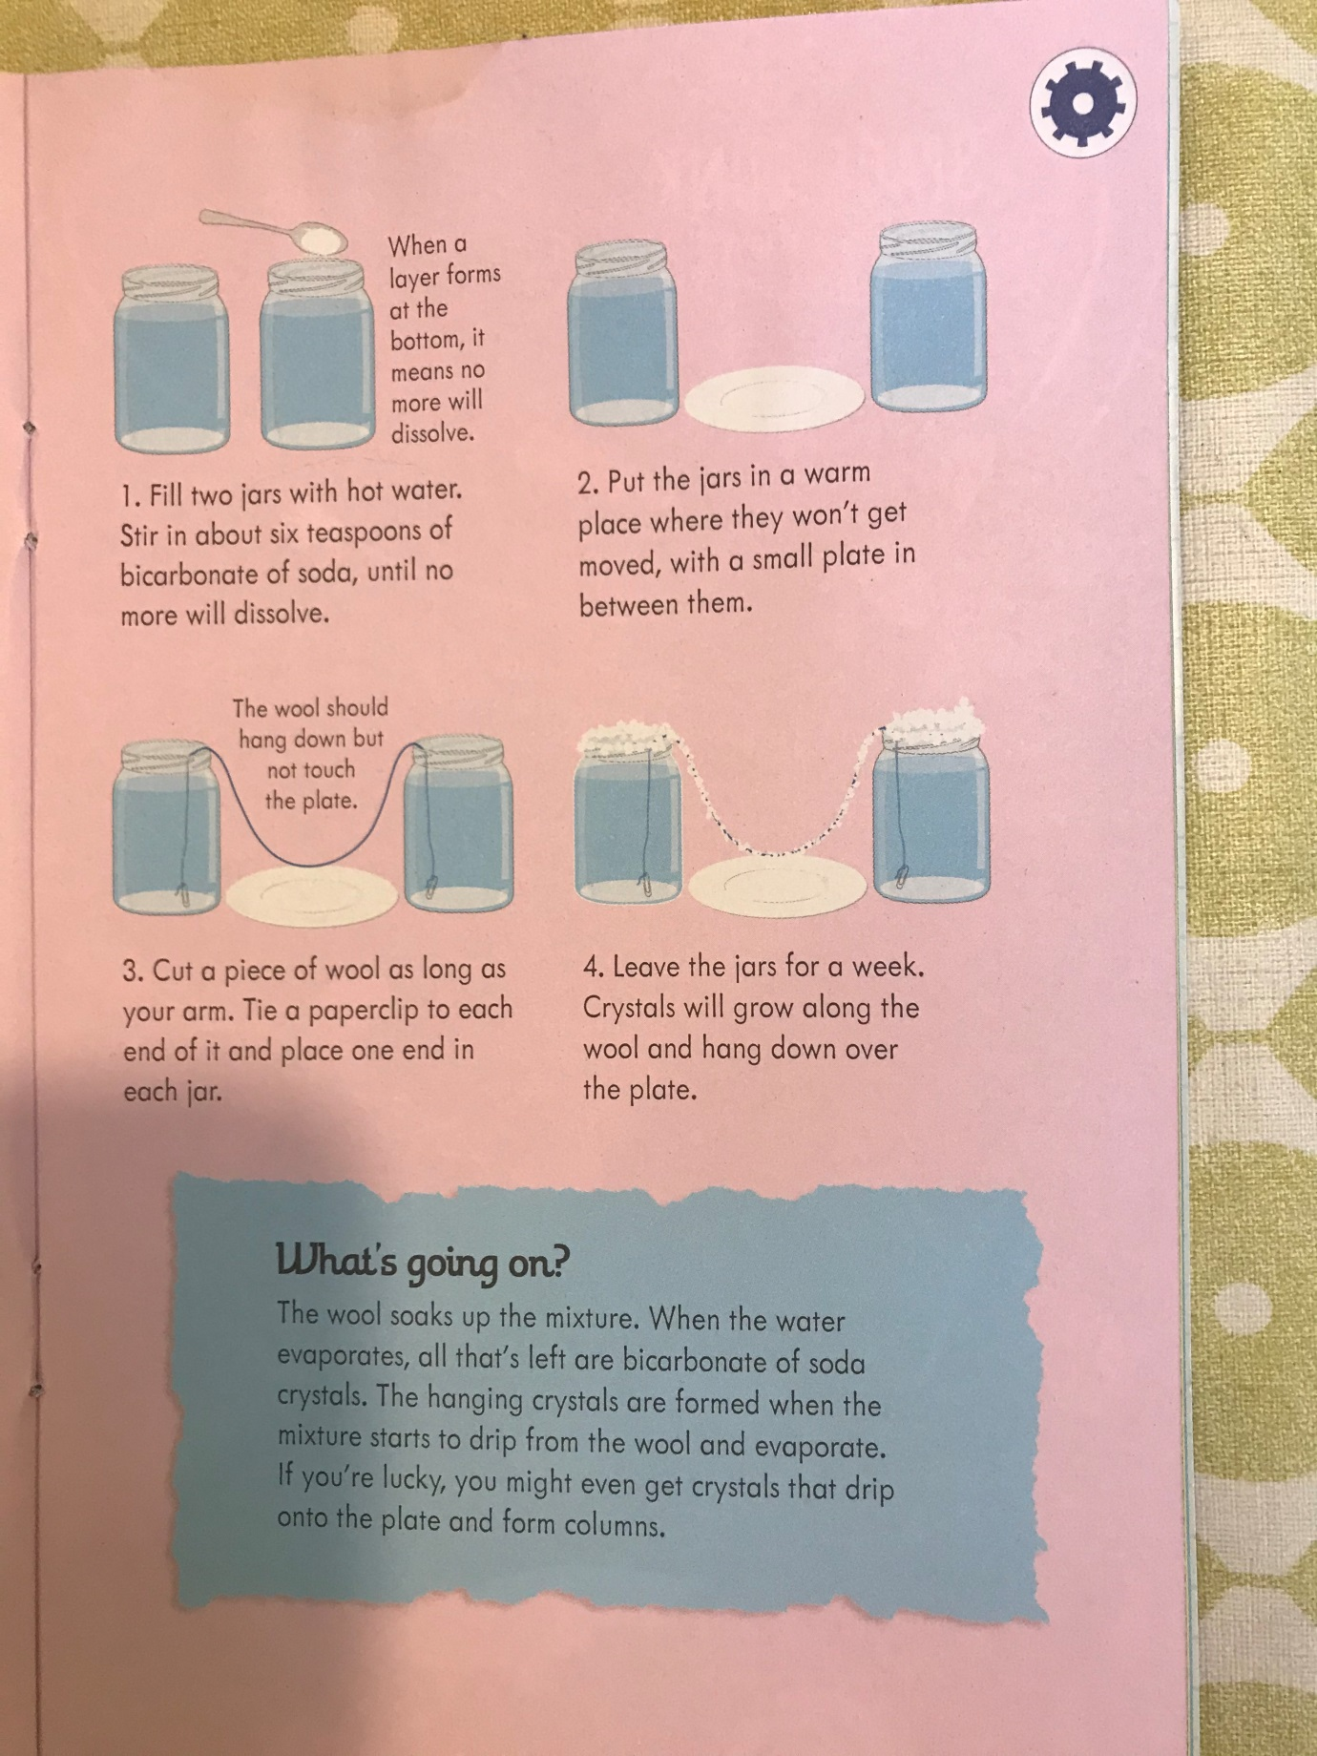

P.E
GAA primary games
Hurling skill challenge video https://www.youtube.com/watch?v=Nhgytua4JeQ

Football skill challenge video - https://www.youtube.com/watch?v=vd3Z9t2G64Y

