June15th – June 19th
4th
We will be going through this on Monday so have a pencil and paper, Planet Maths, Just Grammar, Bua na Cainte and Matilda with you.
Gaeilge:
Note: Séideán Sí This is a good website that provides Irish language activities for children. Choose the Munster version and the Rang a 3-6 class level( the link below should bring you to this). There are spelling, grammar and reading activities to choose from.

https://www.seideansi.ie/rang-a-tri-se.php

Bua na Cainte

Pages 157 and 158, have your book at Zoom and we will go through it.

Reading:
- It is very important to keep reading, don’t forget to keep your book log.
- EPIC

If you want to use Epic it is free until June 30th. if you go to
www.getepic.com/students , and the class code is ess5066

Novel – Matilda

Read Chapters 15, 16 and 17 we will be reading chapter 18 on Zoom on Thursday
Work sheet 16 and 17 and we will take answers at Zoom on Thursday

Spellings:
- Continue with Spellbound and do one unit per week.
Maths:
- Continue with your mental maths, one unit per week.
- Spend 5 mins per day practising your tables ( this is always very important)

Capacity
Topic 26
Pg 157 – 161 , We will cover some of this at zoom.

Writing:
- Don’t forget to write your diary entry each day no matter how small the entries are. It will be very interesting to look back at your diary in years to come and don’t forget to add your ‘three good things’ for each day. Note; this diary is for yourself to keep and read, I will not need to read them.

Just Grammar
Page 34 and 35
Handwriting Book
Continue on for 2 pages

Haiku poems, List poems and Shape poems
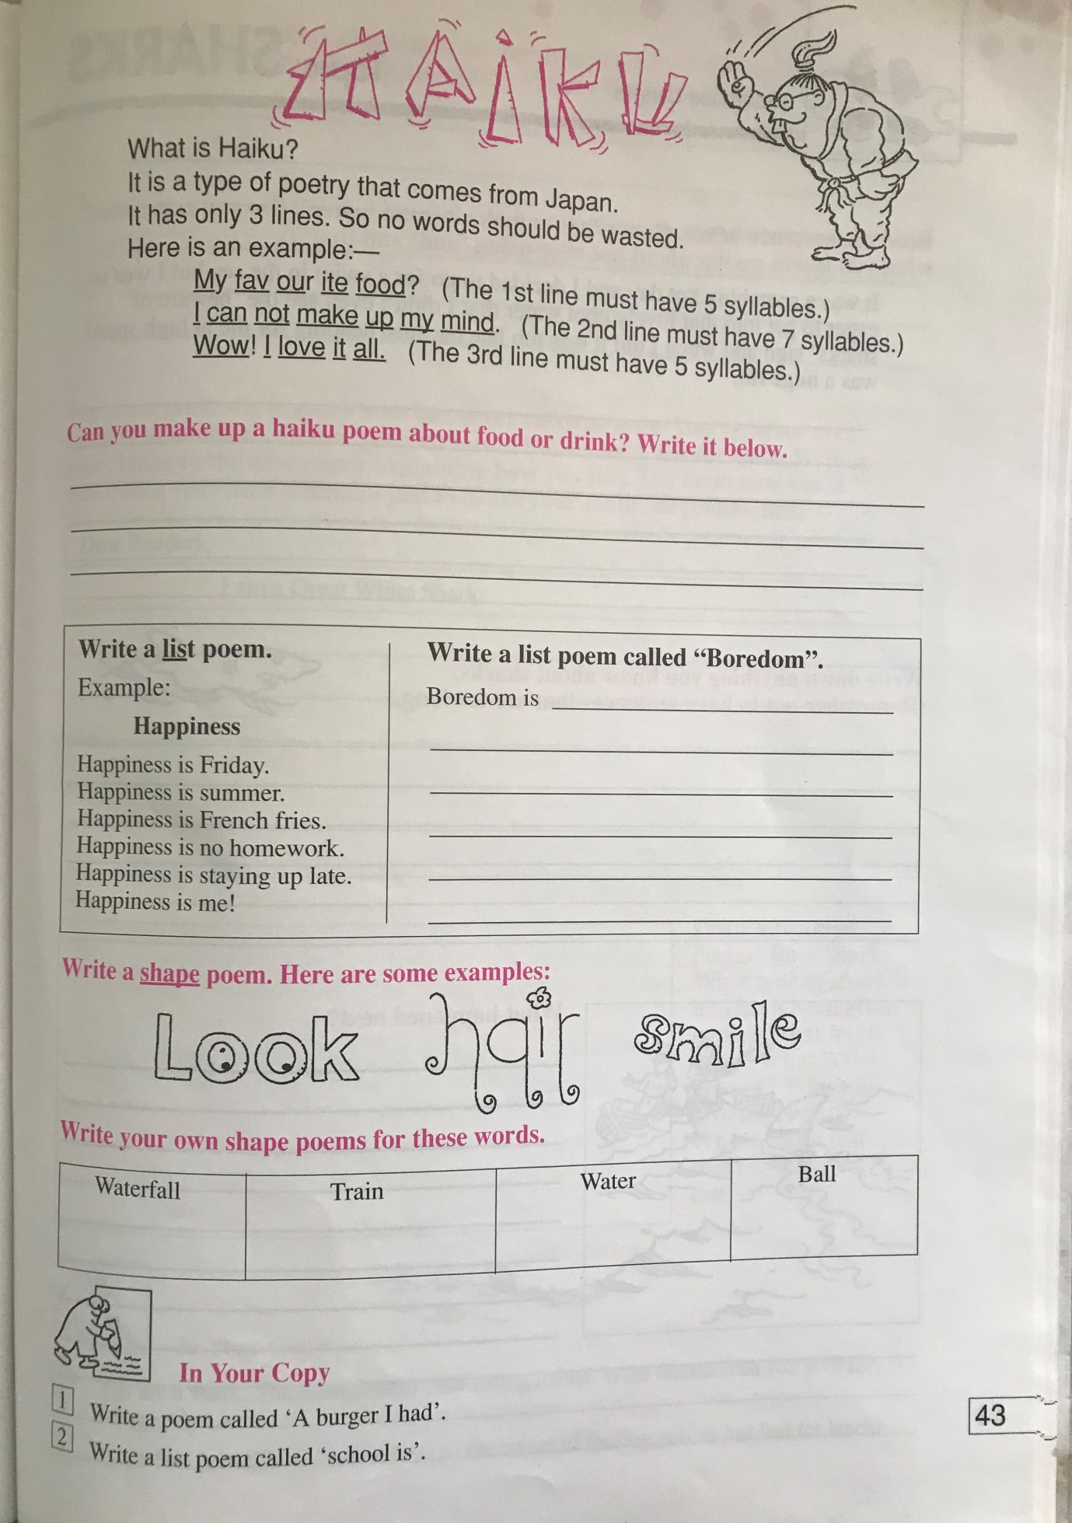

History
Unlocking History
Chapter 12 – Technology

Past and Present/technology Then and Now
https://www.youtube.com/watch?v=DENG7Q7VRgo

