**Outdoor Maths Trail**

**3rd & 4th Class**

**Activities and Challenges:**

What 2-D and 3-D shapes can you see in your garden?

Find one example of symmetry in the garden.

What type of line of symmetry do you see?

Find lines that are vertical, horizontal and parallel.

Face your house. Take one right angle turn to the right. What are you facing now?

Find an example of a right angle in the garden.

Now find angles that are less/more than a right angle.

Estimate (using steps), the length and width of the garden.

Pick a leaf off a tree and draw it below

Does the leaf cover more space than your hand?

Find 2 things that you can completely cover with the leaf.

1................................ 2...........................

Find 2 things that you can't cover with the leaf.

1..............................2........................................

Which has the greater area, the leaf or your hand?

Looking around the garden, what items do you see that are regular shapes and items that you see that have an irregular shape.

|  |  |
| --- | --- |
| Regular Shapes | Irregular Shapes |
|  |  |
|  |  |
|  |  |
|  |  |
|  |  |
|  |  |
|  |  |

If you have flowers or tiny plants (hiding in the grass, like the ones in the pictures):

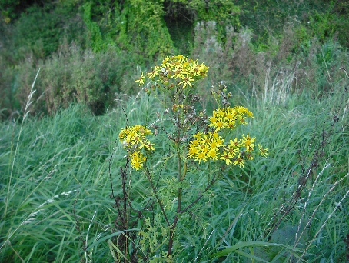 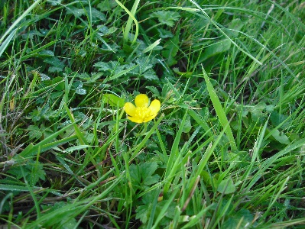 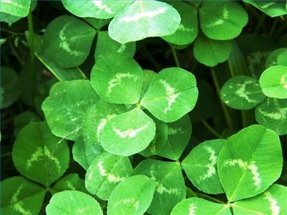

How many petals on the flowers? How many sections are on the leaves of the small green plant? What do these numbers have in common?

|  |  |  |  |
| --- | --- | --- | --- |
| Petals | Petals | Leaf Sections | In common? |
|  |  |  |  |

Soccer pitches look like this:

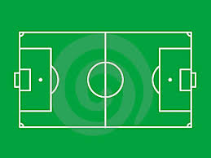How many different shapes are there?

How many different sized rectangles?